How to Setup 5G priority for W15E
Model Number: W15E Question Classification: Function Configuration
Compared with the 2.4G frequency band, 5G frequency band interference is less, transmission speed is faster and more stable，"5G priority function" is specially designed for this function, when function enabled, you need to keep 2.4GHz and 5GHz two bands of SSID and password are the same, and wireless client support dual Wi-Fi, the client connected to a wireless network, will give priority to the 5G band are connected, so as to get the optimal wireless Internet experience.
Step 1: login router settings interface
Step 2: Set wireless name of 2.4G and 5G consistent
Step 3: Turn on the 5G priority function
- Enter www.tendawifi.com in the browser address bar and press enter.
- Enter the password, and click "Login".
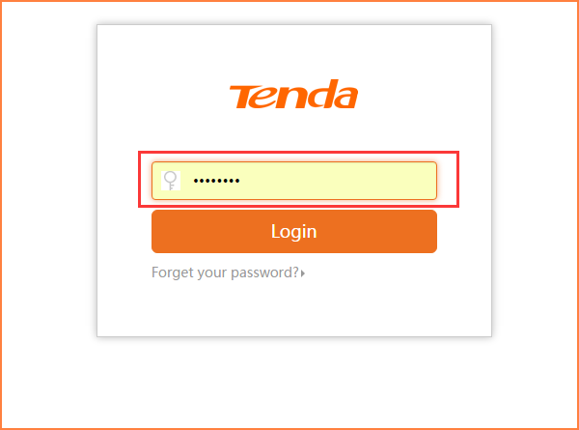
- After the normal login router settings page, you can modify the SSID and password in the "Wireless" - "Basic"
(1)2.4G signal setting
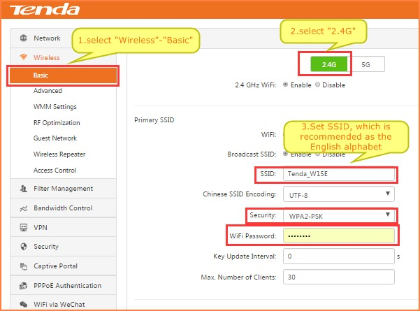
Note: "5G priority" does not support Chinese SSID. Encryption only supports WPA/WPA2.
(2)Maintain 5G signal SSID, encryption mode, the password is consistent with the 2.4G frequency band
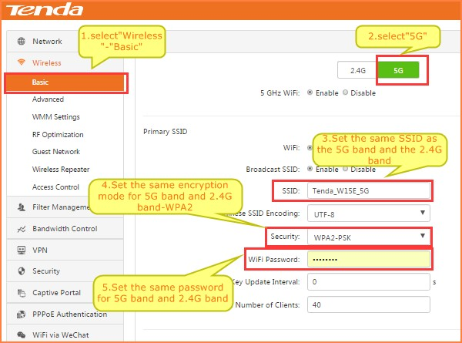
(3)Click "OK""
1. In the “wireless” ---“RF optimization” settings page, turn on the 5G priority function and click “OK"
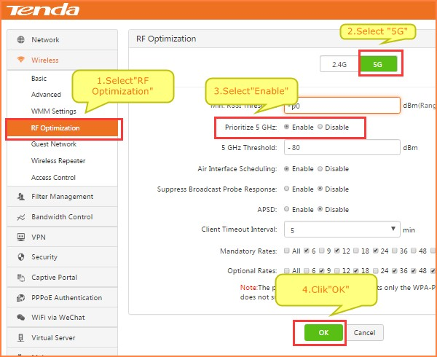
After setting up the above operation, when the dual frequency Wi-Fi wireless terminal is connected to the wireless network, the 5G band will be preferentially selected for connection.

